BATLEDS

USER MANUAL

Volume 1.0

Table of Content:
BATLEDS 1
Table of Content: 2
Preface: 3
Batleds I 30 LED 4
B1 30 Technical Specifications: 4
BI 30 Packaging Information: 5
Installation Guide: 6
Batleds I 42 LED 7
BI 42 Technical Specifications: 7
BI 42 Packaging Information: 8
Installation Guide: 9
Power Supply for B I 30 and B I 42 10
3- Pin Connector 11
Power Line wiring: 11
Recommended Height 12
Batleds II 60 LED 13
B2 60 Technical Specifications: 13
B2 60 Packaging Information: 14
Installation Guide: 15
Batleds II 84 LED 16
BII 84 Technical Specifications: 19
B2 84 Packaging Information: 20
Installation Guide: 21
Recommended Height 22
Complete Lamp Assembly 25
Warranty 26

Preface:
We named our Indoor Lights, BatLEDs due to its appearance like Bats hanging from the ceilings. There are 4 models available and they are certified for CE, IP65 and Full RoHS compliance. Targeted applications: Airports, Railway Stations, Warehouse, Supermarkets, Tunnels, Indoor Sport Arenas and Building exterior lightning.

BatLEDs can be used indoors or outdoors. The are ideal for any continuous lighting application and can reduce electricity consumption and save money on a long term basis.

Batleds I 30 LED
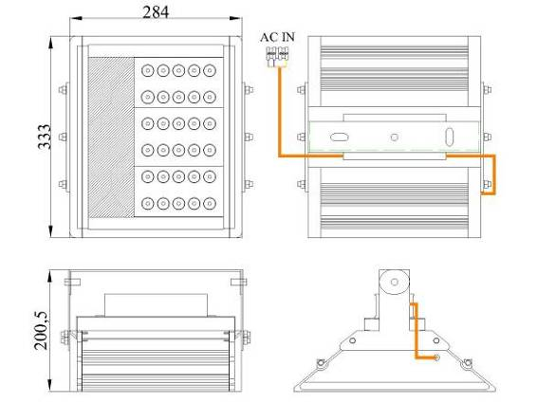
Figure 1

B1 30 Technical Specifications:
Number of LEDs 30
Total Power Consumption 40 watts
LED Type Cree Q5
Total LED Consumption: 34 watts
Power Rating: 220V 50Hz
Power Supply Consumption: 6W
Temperature rating: -40 ºC to 45 ºC
Maximum Operating Temperature <50ºC (Open Air)
LED Initial Flux: 3,210 lm
IP Rating: IP 65
Light Dimensions: 284x333x200.50mm
Warranty on Workmanship 36 Months
Guarantee on LED < 50% loss 60 Months or
(Which ever comes first) 50,000 Hrs

BI 30 Packaging Information:
Net Weight: 14.78 Kg
Gross Weight 16.70 Kg
Carton Size (2 Pc/carton): 760mmx400mmx200mm

Container | Number of Pieces
20 Feet | 1,122
40 Feet | 2,332
40 Feet HQ | 2,756

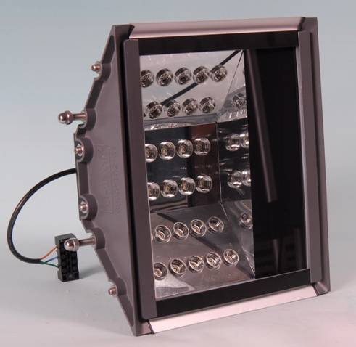
Figure 2

Installation Guide:
There are 2 kinds to install U-Tron Batleds Indoor Lights
1. Using the Wall Mount Method –
This can be use on the wall and whatever angle you may prefer it can be adjusted through the holes. Use the expansion bolt for the concrete wall.

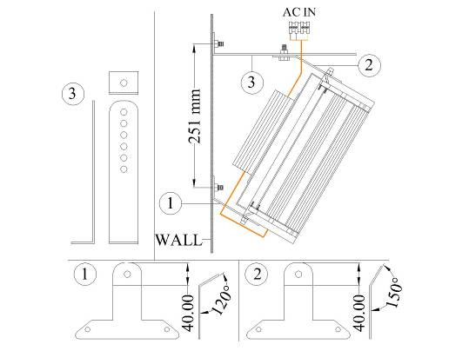

Figure a
2. Using Inverted Tee Mount Method –
This can be use on ware houses that is really high, its because on the weight less advantage you can use a cable to mount the Batleds from the high ceiling.
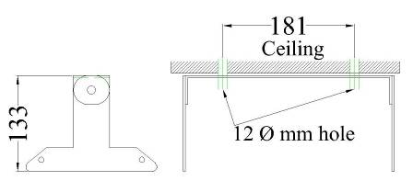
Figure b

Batleds I 42 LED
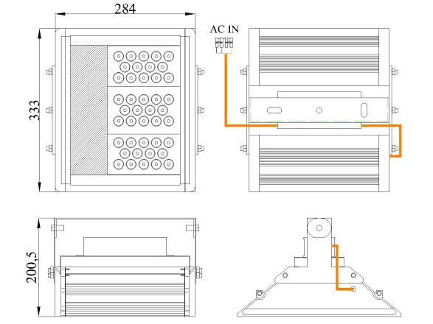
Figure 3

BI 42 Technical Specifications:
Number of LEDs 42
Total Power Consumption 55 watts
LED Type Cree Q5
Total LED Consumption: 48.51 watts
Power Rating: 220V 50Hz
Power Supply Consumption: 7W
Temperature rating: -40 ºC to 45 ºC
Maximum Operating Temperature <50ºC (Open Air)
LED Initial Flux: 4,494lm
IP Rating: IP 65
Light Dimensions: 284x333x200.50mm
Warranty on Workmanship 36 Months
Guarantee on LED < 50% loss 60 Months or
(Which ever comes first) 50,000 Hrs

BI 42 Packaging Information:
Net Weight: 14.78 Kg
Gross Weight 16.70 Kg
Carton Size (1 Pc/carton): 760mmx400mmx200mm

Container | Number of Pieces
20 Feet | 1,122
40 Feet | 2,332
40 Feet HQ | 2,756

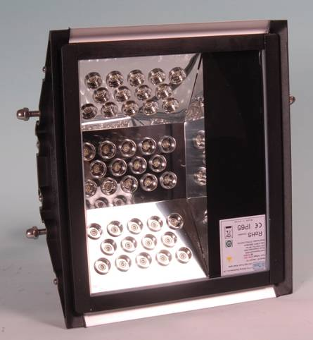
Figure 4

Installation Guide:
There are 2 kinds to install U-Tron Batleds Indoor Lights
1. Using the Wall Mount Method –
This can be use on the wall and whatever angle you may prefer it can be adjusted through the holes. Use the expansion bolt for the concrete wall.

Figure a
2. Using Inverted Tee Mount Method –
This can be use on ware houses that is really high, its because on the weight less advantage you can use a cable to mount the Batleds from the high ceiling.
Figure b

Power Supply for B I 30 and B I 42
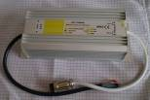
Product Description:
➢ Product Name: Waterproof Constant Voltage LED Driver
➢ High efficiency, energy saving, environmentally friendly
➢ High stability, increase light efficiency and decrease lumen depreciation
➢ Assure LEDs' stability, long life and light efficiency by constant voltage design
➢ Passed high/low temperature and IP67 waterproof testing
➢ Protection against short circuit and thermal overload
➢ Aluminum casing design for better heat dissipation
Technical Specifications:
Model No. | WTF-D24060C
Input | Voltage | 170-250VAC, 90-130VAC (WTF-D24060B)
Input | Frequency | 50-60Hz
Input | Efficiency | 85% typical
Input | Power Factor | > 0.98
Output | Current | 2.5A
Output | Voltage | 24VDC ±0.5VDC
Output | Power | 60W
Protection | Short Circuit | Yes
Protection | Overload | Yes
Temperature | Operating Temperature | -25℃ ~ +50℃
Temperature | Storage Temperature | -20℃ ~ +80℃
Wiring Way | Flying Leads
Warranty | 2 years
Certificate | CE, RoHS
Dimensions: L175*W72*H45mm

3- Pin Connector
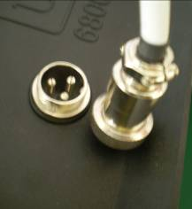 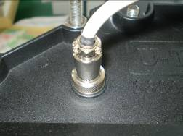
3 pin connector

The three pin connector is an advance feature for the Batleds. For this reason the external power supply is really easy to connect and disconnect. In terms of maintenance process you don't need to open the whole lamp because we guarantee that the power supply will be the first to fail within 3-5 years and it will not require you a lot of time to just change the power supply. This connector is not rated for outdoor purposes (not water proof). If you need water proof connector please specify upon ordering.

Power Line wiring:
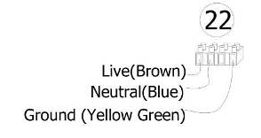
Power Line Installation Guide

Unless otherwise special ordered by the customer, a common 4 prong connector will be supplied with each light. The ground wire is separated by one space for easy recognition. Live and Neutral are color coded to the EU standards, however, there may be variations depending on the country in which you install the lamp. If the external flexible cable or cord of the lamp is damaged, it shall only be replaced by the manufacturer or its service agent or a similar qualified person to avoid danger and the risk of injury

Recommended Height

Model # | Batleds I 30 | Batleds I 42
Ceiling or Wall | 4-5 meters | 5-6 meters

Batleds II 60 LED
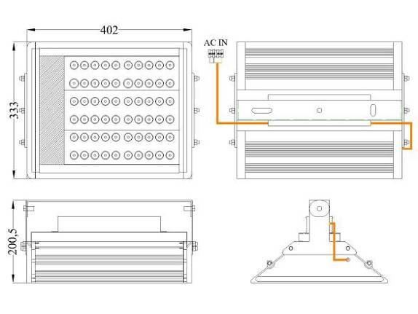
Figure 5

B2 60 Technical Specifications:
Number of LEDs 60
Total Power Consumption 80 watts
LED Type Cree Q5
Total LED Consumption: 69.3 watts
Power Rating: 220V 50Hz
Power Supply Consumption: 10.5W
Temperature rating: -40 ºC to 45 ºC
Maximum Operating Temperature <50ºC (Open Air)
LED Initial Flux: 6,420 lm
IP Rating: IP 65
Lights Dimensions: 402x333x200.50mm
Warranty on Workmanship 36 Months
Guarantee on LED < 50% loss 60 Months or
(Which ever comes first) 50,000 Hrs

B2 60 Packaging Information:
Net Weight: 9.93 Kg (exclude Mounts)
Gross Weight 11.94 Kg
Carton Size (1 Pc/carton): 640x400x200mm
Container | Number of Pieces
20 Feet | 561
40 Feet | 1,166
40 Feet HQ | 1,378

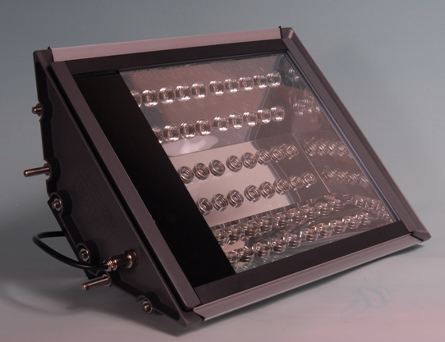
Figure 6

Installation Guide:
There are 2 kinds to install U-Tron Batleds Indoor Lights

1. Using the Adjustable Mount Method –

You can use it either on the ceiling or wall. It has the ability to tilt or adjust the angle of the batleds.
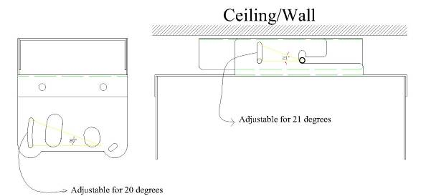
Figure a

2. Using Inverted Tee Mount Method –

This can be use on ware houses that is really high, its because on the weight less advantage you can use a cable to mount the Batleds from the high ceiling.

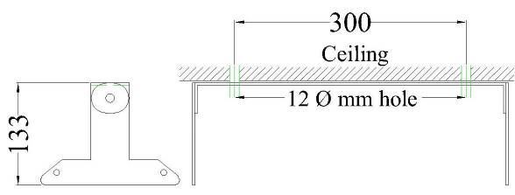
Figure b

Batleds II 84 LED
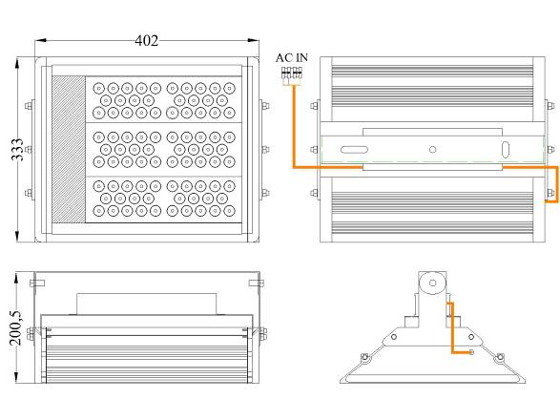
Figure 7

BII 84 Technical Specifications:
Number of LEDs 84
Total Power Consumption 110 watts
LED Type Cree Q5
Total LED Consumption: 96.6 watts
Power Rating: 220V 50Hz
Power Supply Consumption: 10.5W
Temperature rating: -40 ºC to 45 ºC
Maximum Operating Temperature <50ºC (Open Air)
LED Initial Flux: 8,988 lm
IP Rating: IP 65
Lights Dimensions: 402x333x200.50mm
Warranty on Workmanship 36 Months
Guarantee on LED < 50% loss 60 Months or
(Which ever comes first) 50,000 Hrs

B2 84 Packaging Information:
Net Weight: 10.90 Kg
Gross Weight 13.01 Kg
Carton Size (1 Pc/carton): 640x400x200mm
Container | Number of Pieces
20 Feet | 561
40 Feet | 1,166
40 Feet HQ | 1,378

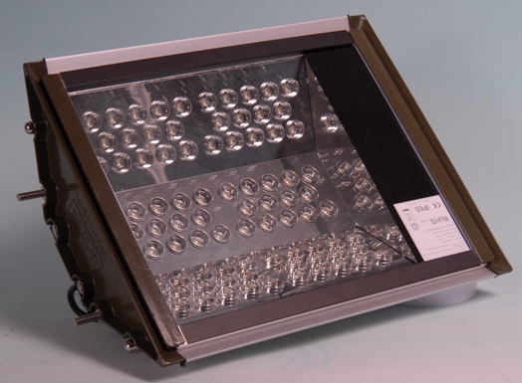
Figure 8

Installation Guide:
There are 2 kinds to install U-Tron Batleds Indoor Lights

Using the Adjustable Mount Method –

You can use it either on the ceiling or wall. It has the ability to tilt or adjust the angle of the batleds.
Figure a

- Using Inverted Tee Mount Method –

This can be use on ware houses that is really high, its because on the weight less advantage you can use a cable to mount the Batleds from the high ceiling.
Figure b

Batleds III 90 LED
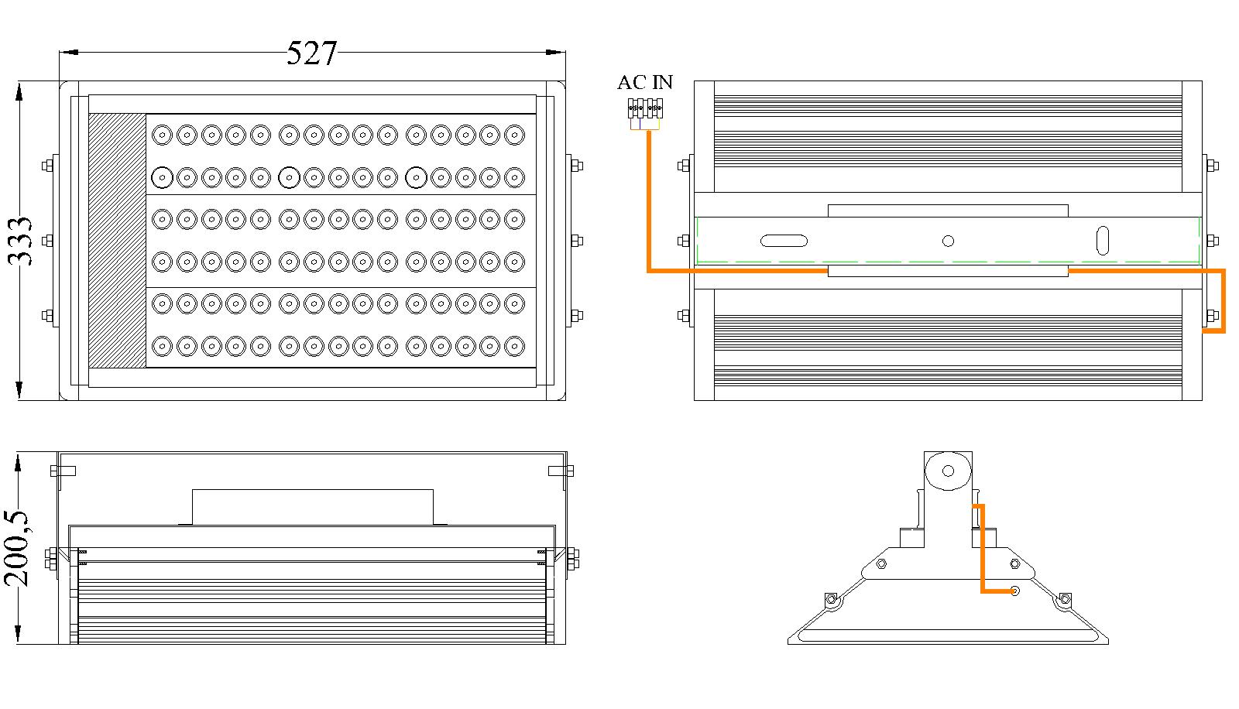
Figure 7

BIII 90 Technical Specifications:
Number of LEDs 90
Total Power Consumption 115 watts
LED Type Cree Q5
Power Rating: 220V 50Hz
Temperature rating: -40 ºC to 45 ºC
Maximum Operating Temperature <50ºC (Open Air)
LED Initial Flux: 9,630 lm
IP Rating: IP 65
Lights Dimensions: 527x333x200.50mm
Warranty on Workmanship 36 Months
Guarantee on LED < 50% loss 60 Months or
(Which ever comes first) 50,000 Hrs

B3 90 Packaging Information:
Net Weight: 15.0 Kg
Gross Weight 16.0 Kg
Carton Size (1 Pc/carton): 640x400x200mm
Container | Number of Pieces
20 Feet | 561
40 Feet | 1,166
40 Feet HQ | 1,378

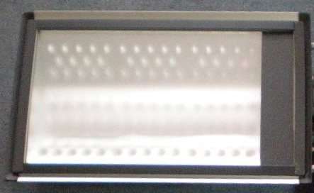

Figure 8

Installation Guide:
There are 2 kinds to install U-Tron Batleds Indoor Lights

Using the Adjustable Mount Method –

You can use it either on the ceiling or wall. It has the ability to tilt or adjust the angle of the batleds.
Figure a

- Using Inverted Tee Mount Method –

This can be use on ware houses that is really high, its because on the weight less advantage you can use a cable to mount the Batleds from the high ceiling.
Figure b

Batleds III 114 LED
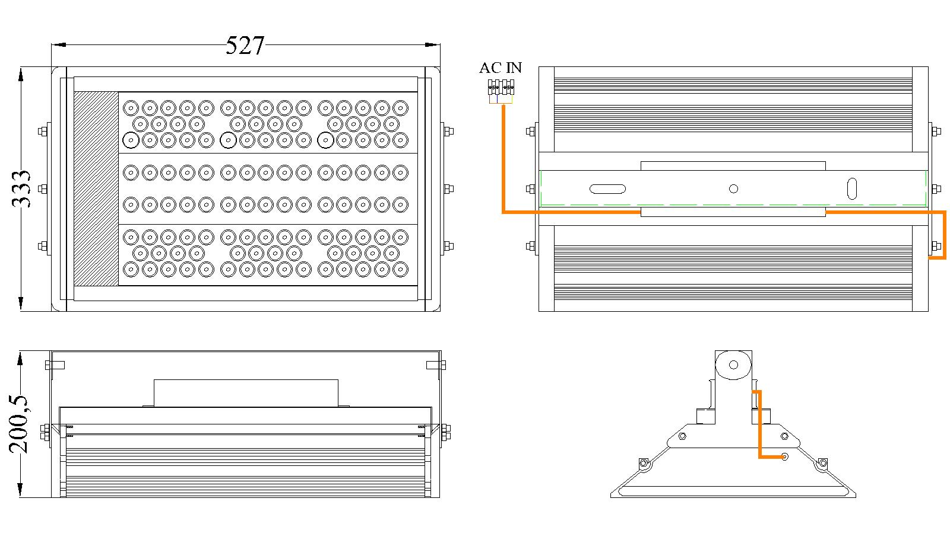
Figure 7

BIII 90 Technical Specifications:
Number of LEDs 114
Total Power Consumption 135 watts
LED Type Cree Q5
Power Rating: 220V 50Hz
Temperature rating: -40 ºC to 45 ºC
Maximum Operating Temperature <50ºC (Open Air)
LED Initial Flux: 12,198 lm
IP Rating: IP 65
Lights Dimensions: 527x333x200.50mm
Warranty on Workmanship 36 Months
Guarantee on LED < 50% loss 60 Months or
(Which ever comes first) 50,000 Hrs

B3 114 Packaging Information:
Net Weight: 15.0 Kg
Gross Weight 16.0 Kg
Carton Size (1 Pc/carton): 640x400x200mm
Container | Number of Pieces
20 Feet | 561
40 Feet | 1,166
40 Feet HQ | 1,378

Figure 8

Installation Guide:
There are 2 kinds to install U-Tron Batleds Indoor Lights

Using the Adjustable Mount Method –

You can use it either on the ceiling or wall. It has the ability to tilt or adjust the angle of the batleds.
Figure a

- Using Inverted Tee Mount Method –

This can be use on ware houses that is really high, its because on the weight less advantage you can use a cable to mount the Batleds from the high ceiling.
Figure b

Recommended Height

Model # | Batleds II 60 | Batleds II 84
Ceiling or Wall | 6-7 meters | 7-8 meters

Complete Lamp Assembly
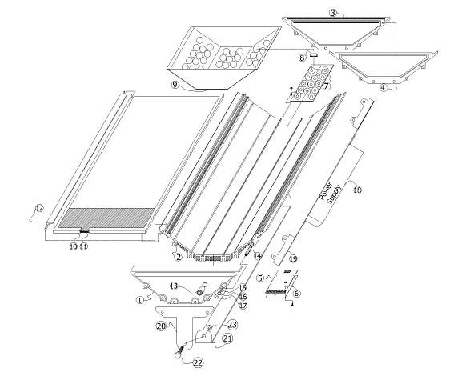

Figure 9

1 - Tail | 7 – LED Board | 13 – IP 68 Connector | 19 – Power Supply Holder
2 – Main Frame | 8 – Reflector Caps | 14 – M8 Stud | 20 – Inverted Tee
3 - Tail | 9 – Reflector Cover | 15 – Flat Washer | 21 – Top Bar
4 - Gasket | 10 – Glass Rubber | 16 – Split Lock Washer | 22 – M12 Hex Bolt
5 – Driver Board | 11 – Glass Cover | 17 – M8 Hex Nut | 23 – M12 Hex Nut
6 – Heat Transfer Sole | 12 – Glass Holder | 18 – Power Supply

Warranty

U-Tron (Beijing) Electronics Co. Ltd., warrants the products listed below for a period of 36 months from the date of shipment to be free from defects in materials or workmanship and to be of the kind and quality designated or specified in the purchase agreement. If any product dose not meets the above warranty and the buyer promptly files a warranty claim U-Tron shall do the following:
U-Tron shall provide a 12 months “No Questions Asked” replacement of any faulty units at no charge to the customer. The time limit for exchange shall not exceed 30 days from the time a claim is filed by the buyers. The buyers shall return the faulty units within 30 days of filing the claim. The method of shipping back the faulty units to U-Tron shall be decided at that time by U-Tron and all shipping charges shall be borne by U-Tron.
At the end of the 12 month period U-Tron shall provide additional free extended warranty for another 24 months. During this 24 months time U-Tron shall repair or replace and re-certify every faulty unit reported. Shipping charges for sending the units to U-Tron shall be the responsibility of the Buyers and the shipping charges to return the repaired goods to the buyer shall be borne by U-Tron. Thetime limit for repairs shall not exceed 60 days.
U-Tron at its own option can elect to provide replacement units at any desired percentage to be warehoused and logged by the buyers for timely service of the extended warranty replacements. When the warranty expires the faulty units and the unused units shall be shipped back to U-Tron unless otherwise stipulated in the contract or purchase agreement. If 90% of the warehoused units are used up or nearing the end of stock, the buyers shall ship back the faulty units to U-Tron. U-Tron shall rotate the spare parts inventory within 60 days of receiving from the buyers.
All warranty claims items shall by shipped to the buyers regardless of the geographical location, by air freight to the nearest airport, and any returning items can be shipped by sea or air freight at the request of U-Tron. If the customer fails to return the said faulty units with in the time frame as instructed, it will be considered as sold and U-Tron reserve the rights to bill the customer for its full value.
U-Tron shall not bare any responsibilities with the buyers customer claims or shall not bare any other expenses incurred other than the units cost it self. Customer site de-installation and re-installation of any faulty units shall not be the responsibilities of U-Tron.
The warranties set forth herein shall be voided if the units have been: 1) Repaired or altered by any unauthorized person. 2) Subjected to misuse, negligence or accidents or operated in other than normal operation and use. 3) Connected, installed or modified in a manner not in accordance with U-Tron instructions.

Applicable models under this warranty:
Street LED Lamps | LED Traffic Lights | Signal Control Products
All Models | All Models | All Cabinet accessories

